EXP 1
Estimation of Characteristic Impedance (Zo), and Propagation Constant (γ) of a Transmission Line from Primary Constants
Test case 1
PROGRAM:

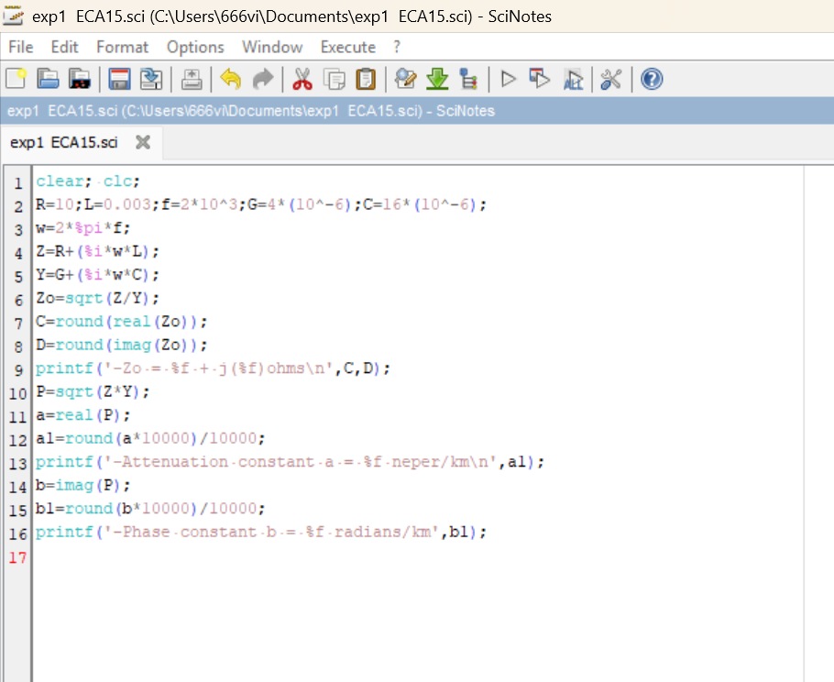

OUTPUT:
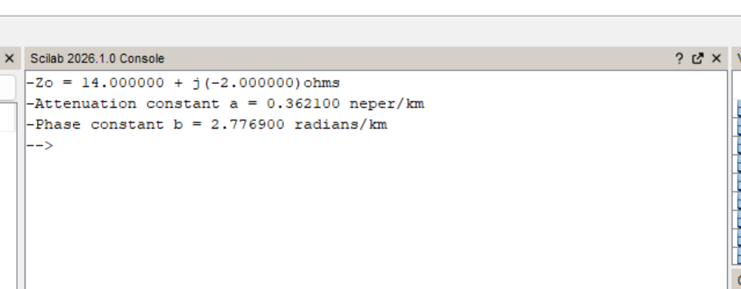

Test case 2
PROGRAM:

OUTPUT:

Test case 3

PROGRAM:

OUTPUT:

